Android Development End Sem Lab exam

Koushik Panchadarla

CH.EN.U4CYS21052

Codes (with file names):

activity_main.xml

<LinearLayout xmlns:android="http://schemas.android.com/apk/res/android"  
 android:layout_width="match_parent"  
 android:layout_height="match_parent"  
 android:orientation="vertical"  
 android:padding="16dp"  
 android:gravity="center"  
 android:background="@drawable/background_image">  
  
 <!-- Text for name and ID -->  
 <TextView  
 android:layout_width="wrap_content"  
 android:layout_height="wrap_content"  
 android:text="Koushik Panchadarla"  
 android:textSize="24sp"  
 android:textColor="#FFFFFF"  
 android:layout_gravity="center"  
 android:padding="12dp"  
 android:textStyle="bold" />  
  
 <TextView  
 android:layout_width="wrap_content"  
 android:layout_height="wrap_content"  
 android:text="CH.EN.U4CYS21052"  
 android:textSize="18sp"  
 android:textColor="#FFFFFF"  
 android:layout_gravity="center"  
 android:padding="12dp" />  
  
 <!-- Button for getting current location -->  
 <Button  
 android:id="@+id/getLocationBtn"  
 android:layout_width="match_parent"  
 android:layout_height="wrap_content"  
 android:layout_marginBottom="24dp"  
 android:textColor="#FFFFFF"  
 android:text="Get Current Location"  
 android:textSize="18sp"  
 android:padding="12dp"  
 android:layout_gravity="center"  
 android:elevation="4dp"  
 android:background="@drawable/button_rounded" />  
  
 <!-- Latitude TextView -->  
 <TextView  
 android:id="@+id/latText"  
 android:layout_width="wrap_content"  
 android:layout_height="wrap_content"  
 android:text="Latitude: "  
 android:textSize="22sp"  
 android:textColor="#FFFFFF"  
 android:layout_gravity="center"  
 android:padding="12dp"  
 android:textStyle="bold" />  
  
 <!-- Longitude TextView -->  
 <TextView  
 android:id="@+id/lonText"  
 android:layout_width="wrap_content"  
 android:layout_height="wrap_content"  
 android:text="Longitude: "  
 android:textSize="22sp"  
 android:textColor="#FFFFFF"  
 android:layout_gravity="center"  
 android:padding="12dp"  
 android:textStyle="bold" />  
  
 <!-- Button for navigating to Google Maps -->  
 <Button  
 android:id="@+id/navigateBtn"  
 android:layout_width="match_parent"  
 android:layout_height="wrap_content"  
 android:layout_marginTop="24dp"  
 android:textColor="#FFFFFF"  
 android:text="Navigate to Google Maps"  
 android:textSize="18sp"  
 android:padding="12dp"  
 android:elevation="4dp"  
 android:drawableLeft="@drawable/ic_google_maps"  
 android:drawablePadding="8dp"  
 android:layout_gravity="center"  
 android:background="@drawable/button_border" />  
  
</LinearLayout>

MainActivity.java

package com.example.gpsmaps;  
  
import android.Manifest;  
import android.content.Intent;  
import android.content.pm.PackageManager;  
import android.net.Uri;  
import android.os.Bundle;  
import android.widget.Button;  
import android.widget.TextView;  
import android.widget.Toast;  
  
import androidx.annotation.NonNull;  
import androidx.appcompat.app.AppCompatActivity;  
import androidx.core.app.ActivityCompat;  
  
import com.google.android.gms.location.FusedLocationProviderClient;  
import com.google.android.gms.location.LocationServices;  
import com.google.android.gms.tasks.OnSuccessListener;  
import com.google.firebase.database.DatabaseReference;  
import com.google.firebase.database.FirebaseDatabase;  
  
import android.location.Location;  
  
public class MainActivity extends AppCompatActivity {  
  
 private FusedLocationProviderClient fusedLocationClient;  
 private TextView latText, lonText;  
 private Button getLocationBtn, navigateBtn;  
 private double latitude, longitude;  
 private DatabaseReference mDatabase;  
  
 @Override  
 protected void onCreate(Bundle savedInstanceState) {  
 super.onCreate(savedInstanceState);  
 setContentView(R.layout.*activity_main*);  
  
 // Initialize Firebase Realtime Database  
 mDatabase = FirebaseDatabase.*getInstance*().getReference("locations");  
  
 // Initialize FusedLocationProviderClient for location data  
 fusedLocationClient = LocationServices.*getFusedLocationProviderClient*(this);  
  
 // UI elements  
 latText = findViewById(R.id.*latText*);  
 lonText = findViewById(R.id.*lonText*);  
 getLocationBtn = findViewById(R.id.*getLocationBtn*);  
 navigateBtn = findViewById(R.id.*navigateBtn*);  
  
 // Button to get current location  
 getLocationBtn.setOnClickListener(v -> getLocation());  
  
 // Button to navigate to Google Maps using current coordinates  
 navigateBtn.setOnClickListener(v -> navigateToMaps());  
 }  
  
 // Fetches current location and updates Firebase and UI  
 private void getLocation() {  
 // Check if location permission is granted  
 if (ActivityCompat.*checkSelfPermission*(this, Manifest.permission.*ACCESS_FINE_LOCATION*) != PackageManager.*PERMISSION_GRANTED*) {  
 ActivityCompat.*requestPermissions*(this, new String[]{Manifest.permission.*ACCESS_FINE_LOCATION*}, 1);  
 return;  
 }  
  
 // Get last known location  
 fusedLocationClient.getLastLocation()  
 .addOnSuccessListener(this, new OnSuccessListener<Location>() {  
 @Override  
 public void onSuccess(Location location) {  
 if (location != null) {  
 // Fetch latitude and longitude  
 latitude = location.getLatitude();  
 longitude = location.getLongitude();  
  
 // Display coordinates in TextViews  
 latText.setText("Latitude: " + latitude);  
 lonText.setText("Longitude: " + longitude);  
  
 // Store the coordinates in Firebase  
 storeLocationInFirebase(latitude, longitude);  
  
 Toast.*makeText*(MainActivity.this, "Location stored in Firebase!", Toast.*LENGTH_SHORT*).show();  
 } else {  
 Toast.*makeText*(MainActivity.this, "Unable to get location!", Toast.*LENGTH_SHORT*).show();  
 }  
 }  
 });  
 }  
  
 // Navigate to Google Maps using the latitude and longitude  
 private void navigateToMaps() {  
 if (latitude != 0.0 && longitude != 0.0) {  
 String uri = "geo:" + latitude + "," + longitude + "?q=" + latitude + "," + longitude;  
 Intent intent = new Intent(Intent.*ACTION_VIEW*, Uri.*parse*(uri));  
  
 // Specify the Google Maps package  
 intent.setPackage("com.google.android.apps.maps");  
  
 try {  
 startActivity(intent);  
 } catch (Exception e) {  
 Toast.*makeText*(this, "Google Maps is not installed!", Toast.*LENGTH_SHORT*).show();  
 }  
 } else {  
 Toast.*makeText*(this, "No location to navigate to.", Toast.*LENGTH_SHORT*).show();  
 }  
 }  
  
  
 // Store the fetched coordinates in Firebase Realtime Database  
 private void storeLocationInFirebase(double lat, double lon) {  
 LocationData locationData = new LocationData(lat, lon);  
 mDatabase.push().setValue(locationData);  
 }  
  
 // Request permission result callback  
 @Override  
 public void onRequestPermissionsResult(int requestCode, @NonNull String[] permissions, @NonNull int[] grantResults) {  
 super.onRequestPermissionsResult(requestCode, permissions, grantResults);  
 if (requestCode == 1) {  
 if (grantResults.length > 0 && grantResults[0] == PackageManager.*PERMISSION_GRANTED*) {  
 getLocation();  
 }  
 }  
 }  
  
 // Class to represent location data  
 public static class LocationData {  
 public double latitude;  
 public double longitude;  
  
 public LocationData() {  
 // Default constructor required for Firebase  
 }  
  
 public LocationData(double latitude, double longitude) {  
 this.latitude = latitude;  
 this.longitude = longitude;  
 }  
 }  
}

Android_Manifest.xml

<?xml version="1.0" encoding="utf-8"?>  
<manifest xmlns:android="http://schemas.android.com/apk/res/android"  
 xmlns:tools="http://schemas.android.com/tools">  
  
 <application  
 android:allowBackup="true"  
 android:dataExtractionRules="@xml/data_extraction_rules"  
 android:fullBackupContent="@xml/backup_rules"  
 android:icon="@mipmap/amrita"  
 android:label="Geo Navigator"  
 android:roundIcon="@mipmap/amrita"  
 android:supportsRtl="true"  
 android:theme="@style/Theme.Gpsmaps"  
 tools:targetApi="31">  
 <activity  
 android:name=".MainActivity"  
 android:exported="true">  
 <intent-filter>  
 <action android:name="android.intent.action.MAIN" />  
  
 <category android:name="android.intent.category.LAUNCHER" />  
 </intent-filter>  
 </activity>  
 </application>  
  
 <uses-permission android:name="android.permission.ACCESS_FINE_LOCATION"/>  
 <uses-permission android:name="android.permission.ACCESS_COARSE_LOCATION"/>  
  
</manifest>

button_border.xml

<?xml version="1.0" encoding="utf-8"?>  
<manifest xmlns:android="http://schemas.android.com/apk/res/android"  
 xmlns:tools="http://schemas.android.com/tools">  
  
 <application  
 android:allowBackup="true"  
 android:dataExtractionRules="@xml/data_extraction_rules"  
 android:fullBackupContent="@xml/backup_rules"  
 android:icon="@mipmap/amrita"  
 android:label="Geo Navigator"  
 android:roundIcon="@mipmap/amrita"  
 android:supportsRtl="true"  
 android:theme="@style/Theme.Gpsmaps"  
 tools:targetApi="31">  
 <activity  
 android:name=".MainActivity"  
 android:exported="true">  
 <intent-filter>  
 <action android:name="android.intent.action.MAIN" />  
  
 <category android:name="android.intent.category.LAUNCHER" />  
 </intent-filter>  
 </activity>  
 </application>  
  
 <uses-permission android:name="android.permission.ACCESS_FINE_LOCATION"/>  
 <uses-permission android:name="android.permission.ACCESS_COARSE_LOCATION"/>  
  
</manifest>

button_rounded.xml

<?xml version="1.0" encoding="utf-8"?>  
<shape xmlns:android="http://schemas.android.com/apk/res/android" android:shape="rectangle">  
 <corners android:radius="25dp" />  
 <solid android:color="?android:attr/colorButtonNormal" />  
 <padding android:left="16dp" android:top="10dp" android:right="16dp" android:bottom="10dp" />  
</shape>

background_gradient.xml

<?xml version="1.0" encoding="utf-8"?>  
<layer-list xmlns:android="http://schemas.android.com/apk/res/android">  
 <item>  
 <shape android:shape="rectangle">  
 <gradient  
 android:angle="45"  
 android:startColor="#212121"  
 android:endColor="#424242"  
 android:type="linear" />  
 </shape>  
 </item>  
</layer-list>

Installing dependencies and implementations necessary for obtaining location, accessing real-time firebase. Sync gradle after modifying these:

build.gradle.kts(Module:app)

plugins **{** id("com.android.application")  
 id("com.google.gms.google-services")  
**}***android* **{** namespace = "com.example.gpsmaps"  
 compileSdk = 34  
  
 defaultConfig **{** applicationId = "com.example.gpsmaps"  
 minSdk = 29  
 targetSdk = 34  
 versionCode = 1  
 versionName = "1.0"  
  
 testInstrumentationRunner = "androidx.test.runner.AndroidJUnitRunner"  
 **}** buildTypes **{** *release* **{** isMinifyEnabled = false  
 proguardFiles(  
 getDefaultProguardFile("proguard-android-optimize.txt"),  
 "proguard-rules.pro"  
 )  
 **}  
 }** compileOptions **{** sourceCompatibility = JavaVersion.*VERSION_1_8* targetCompatibility = JavaVersion.*VERSION_1_8* **}  
}***dependencies* **{** *implementation*(platform("com.google.firebase:firebase-bom:33.4.0"))  
 *implementation*("com.google.android.gms:play-services-location:21.0.1")  
 *implementation*("com.google.firebase:firebase-analytics")  
 *implementation*("com.google.firebase:firebase-database-ktx:20.0.5")  
 *implementation*(*libs*.*appcompat*)  
 *implementation*(*libs*.*material*)  
 *implementation*(*libs*.*activity*)  
 *implementation*(*libs*.*constraintlayout*)  
 *testImplementation*(*libs*.*junit*)  
 *androidTestImplementation*(*libs*.*ext*.*junit*)  
 *androidTestImplementation*(*libs*.*espresso*.*core*)  
**}**

build.gradle.kts(Project:gpsmaps)

// Top-level build file where you can add configuration options common to all sub-projects/modules.  
plugins **{** alias(*libs*.*plugins*.*android*.*application*) *apply* false  
 id("com.google.gms.google-services") *version* "4.4.2" *apply* false  
**}**

Outputs (screenshots):

Application installed on Android device

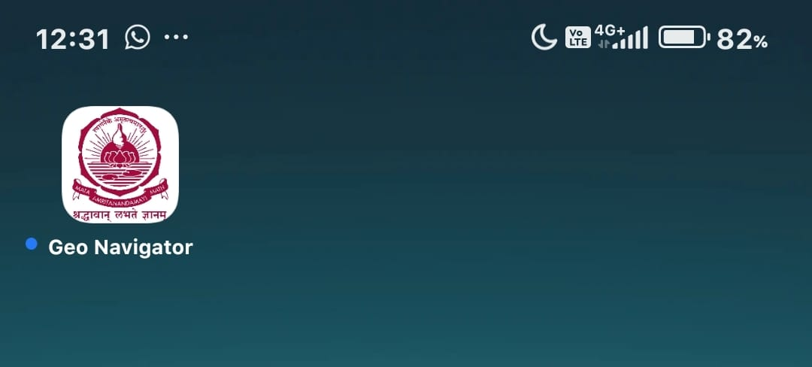

Application in action:

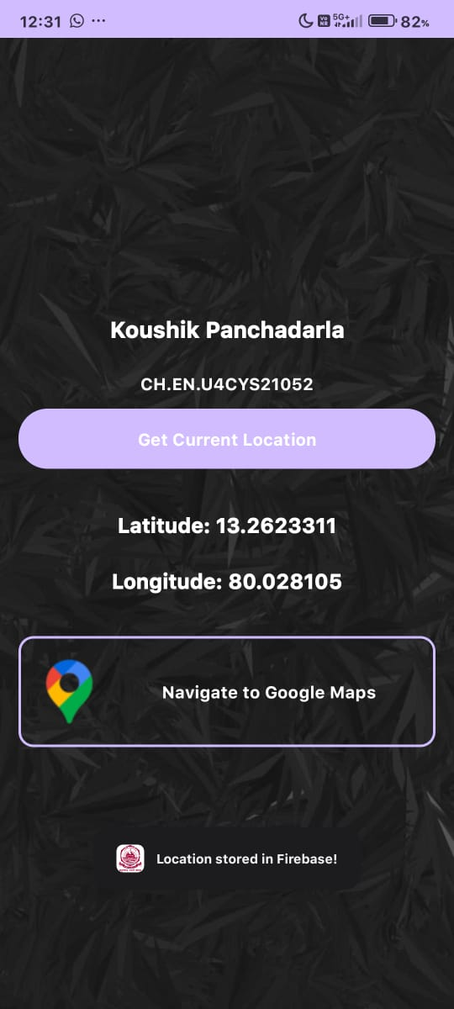

On clicking the Get current Location button, you will receive a toast message that your location is directly uploaded into Firebase.

Firebase’s real-time database contents after obtaining location:

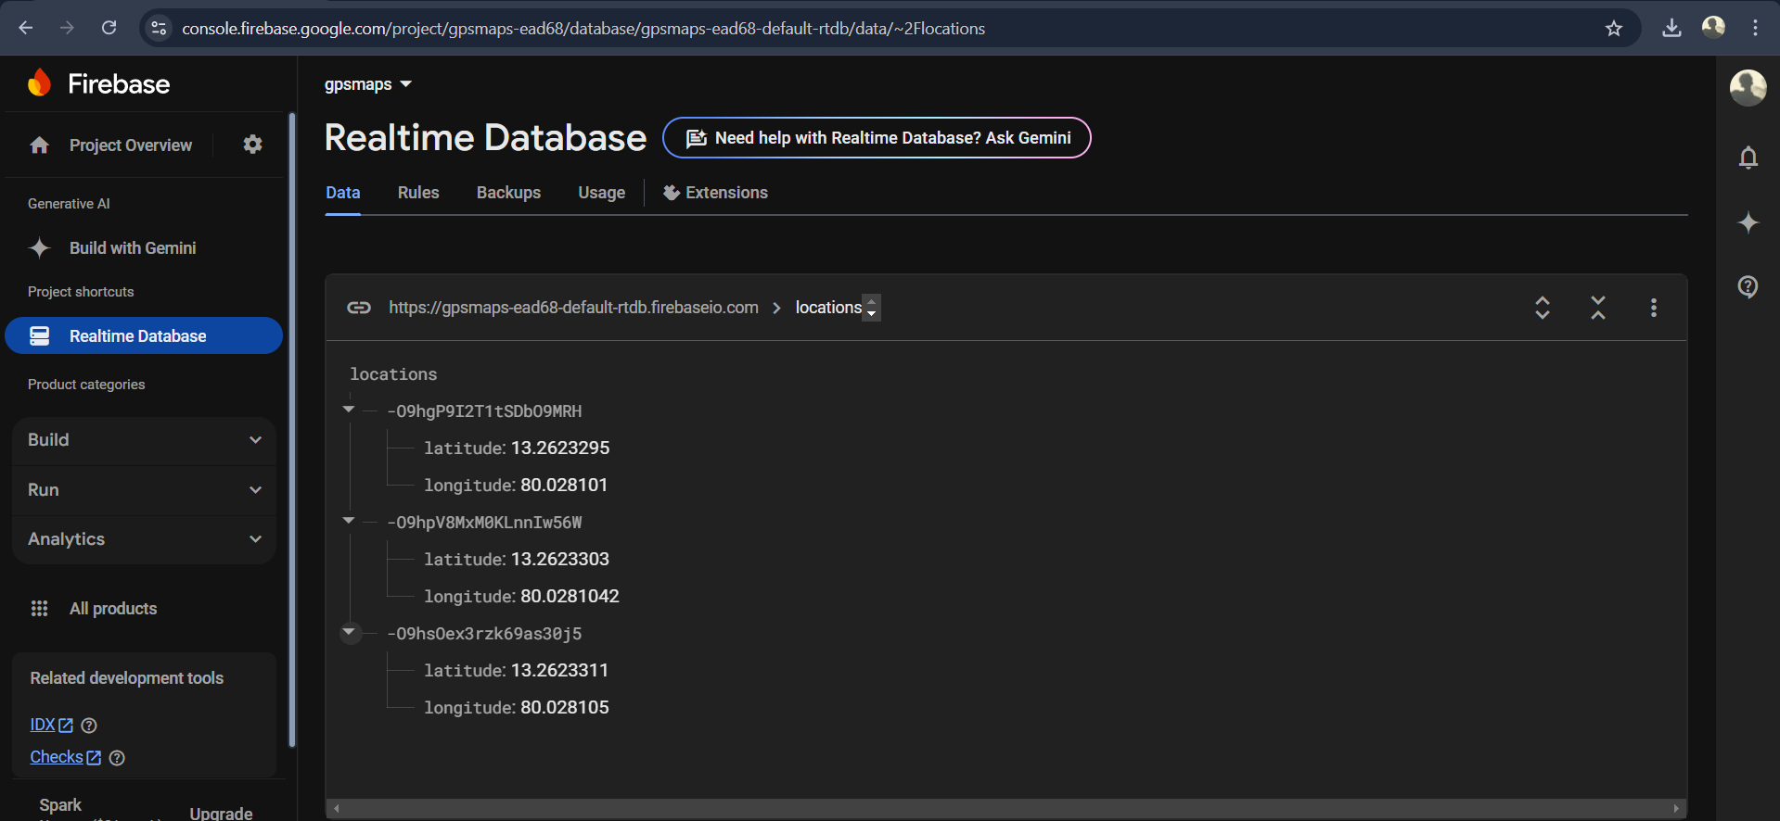

On clicking “Navigate to Google Maps”:

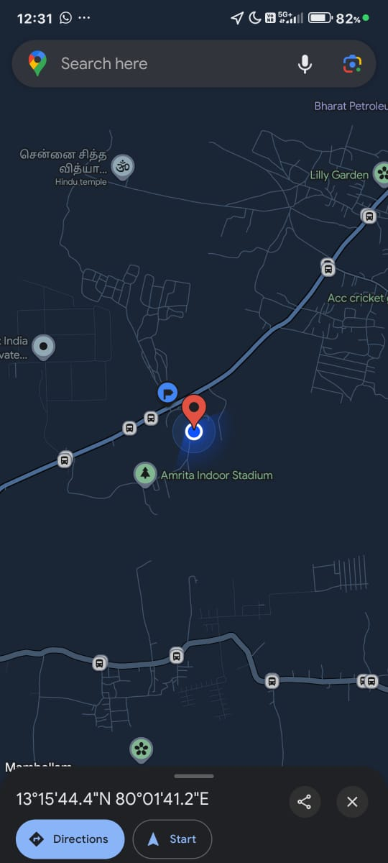

- The End -